White Balancing Project

Short Report

White balance is basically the color temperature in an image. It adds the opposite color to the image in an attempt to bring the color temperature back to neutral. In our project we tried to implement this program, so that the opposite color to the image is added in the attempt to bring the color temperature back to neutral. And the end result turned out correct, where the white appear correctly on the image.

**BEFORE AFTER**

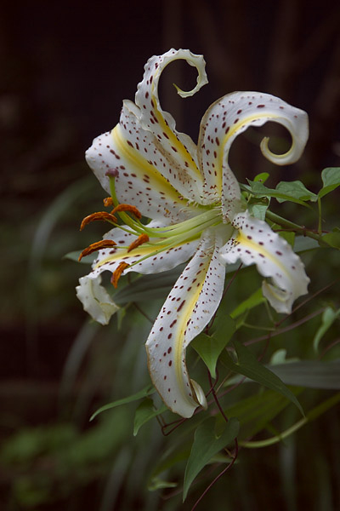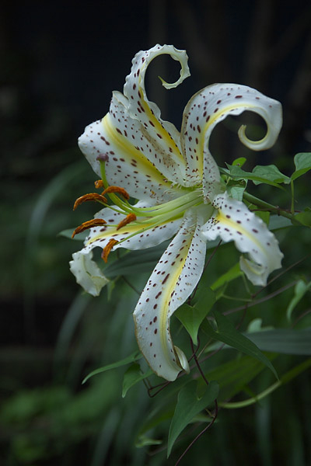

Now, getting into the detail of our code and how we made this possible.

1. The first step was to import the image, and plot image along with a grid so we can easily find gray reference point on the image, which will be using in the later steps
2. We check whether the alpha channel exists in the image. If yes, then keep note of this
3. We then plot a sub-portion of the original image from the position our gray reference from the image and its size appointed by us. If an alpha channel exists in the image, we need to perform an array slicing to remove this channel
4. Using a conversion algorithm from stackoverflow, we converted the original image and sub-portioned image from rgb to ycbcr
5. We then find the means of ycbcr components of the sample and use that to centralize the cb and cr components of the original image in ycbcr
6. We then convert the original image back from ycbcr to rgb and plot them into an image